

Handwritten character and digit recognition

Using Convolutional Neural Networks



**Name: Sri sai vijaya aditya nittala**

**roll no.: 177163**

**Section: A**

In this assignment the following questions have been implemented using Convolutional Neural Networks:

1. Handwritten character recognition (EMNIST dataset)
2. Handwritten digit recognition (MNIST dataset)

Firstly, lets look at the network architecture for the handwritten digit recognition network:

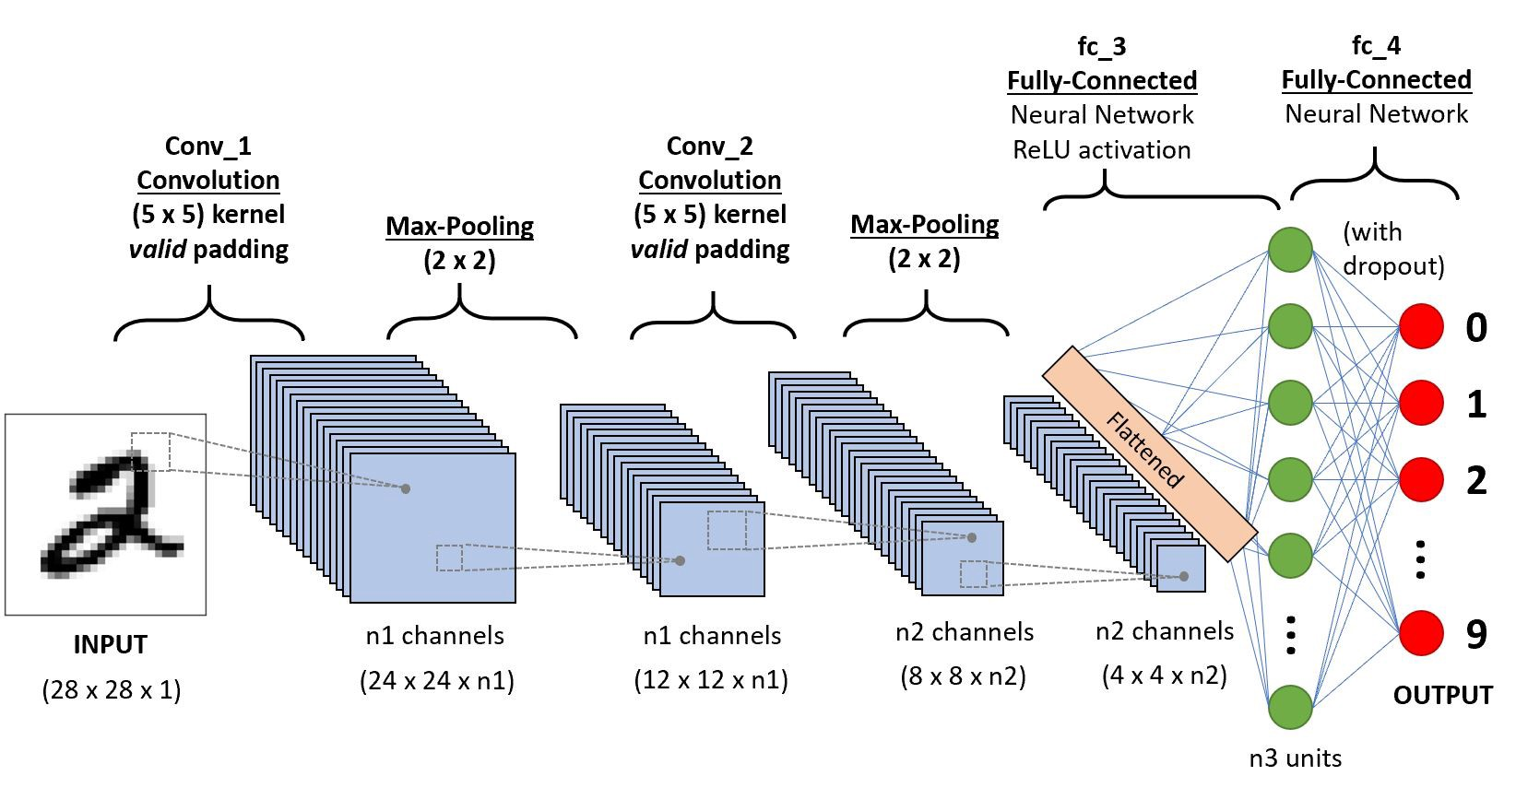

* Convolutions help to bring out the structure in the image.
* Pooling reduces the size of the image, summarizing the patterns.

The network architecture for the handwritten character recognition is the same as the above network. The input is different.

**MNIST Dataset:**

* 28x28 size for the images
* Labels from 0-9

**EMNIST Dataset:**

* 28x28 size for the images
* Labels from 0-25

**Below, I have attached the downloaded .pdf files for both the notebooks.**